DAILY ONLINE ACTIVITIES SUMMARY

|  |  |  |  |  |  |  |  |
| --- | --- | --- | --- | --- | --- | --- | --- |
| **Date:** | **01-06-2020** | | | | **Name:** | **Apoorva H P** | |
| **Sem & Sec** | **VI A** | | | | **USN:** | **4AL17CS011** | |
| Online Test Summary | | | | | | | |
| **Subject** | | **CNSC IA 2 Test** | | | | | |
| **Max. Marks** | | **60** | | **Score** | | **52** | |
| Certification Course Summary | | | | | | | |
| **Course** | **Machine learning with python** | | | | | | |
| **Certificate Provider** | | | **Congnitive Class** | **Duration** | | | **6hr** |
| Coding Challenges | | | | | | | |
| **Problem Statement:**  1.Python program to delete duplicate elements from the list 2.Python Program to remove duplicate elements from a list | | | | | | | |
| **Status: Completed** | | | | | | | |
| **Uploaded the report in GitHub** | | | | **Yes** | | | |
| **If yes Repository name** | | | | <https://github.com/ashaapoorva/online-coding-and-certification-course> | | | |
| **Uploaded the report in slack** | | | | **Yes** | | | |

Online test Detail:

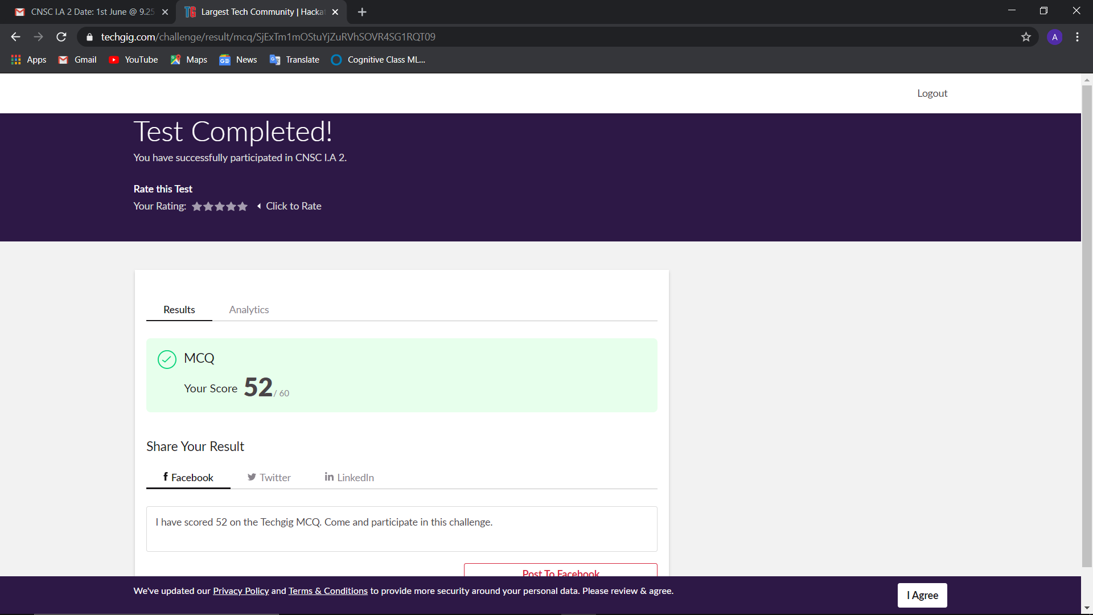

Online Certification Details

Modules completed:

Module 4:Clustering

-Learning objectives

-Intro to clustering

-K-means clustering

-More on K-means

-Hierarchical clustering

-More on Hierarchical clustering

-DBSCAN clustering

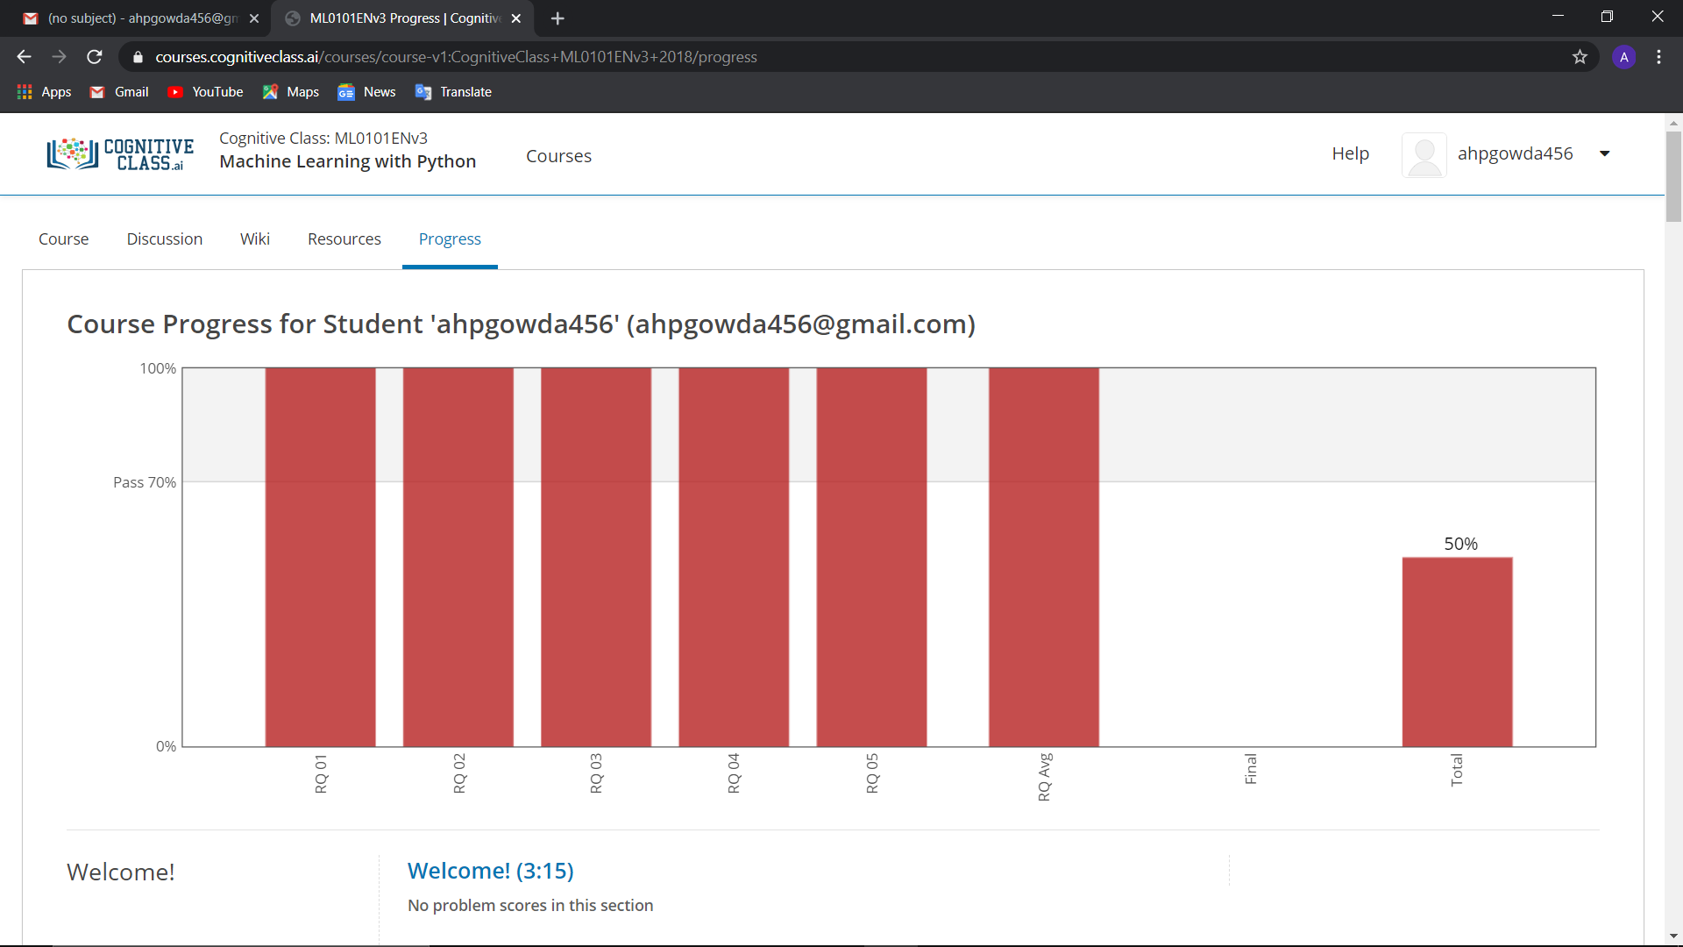

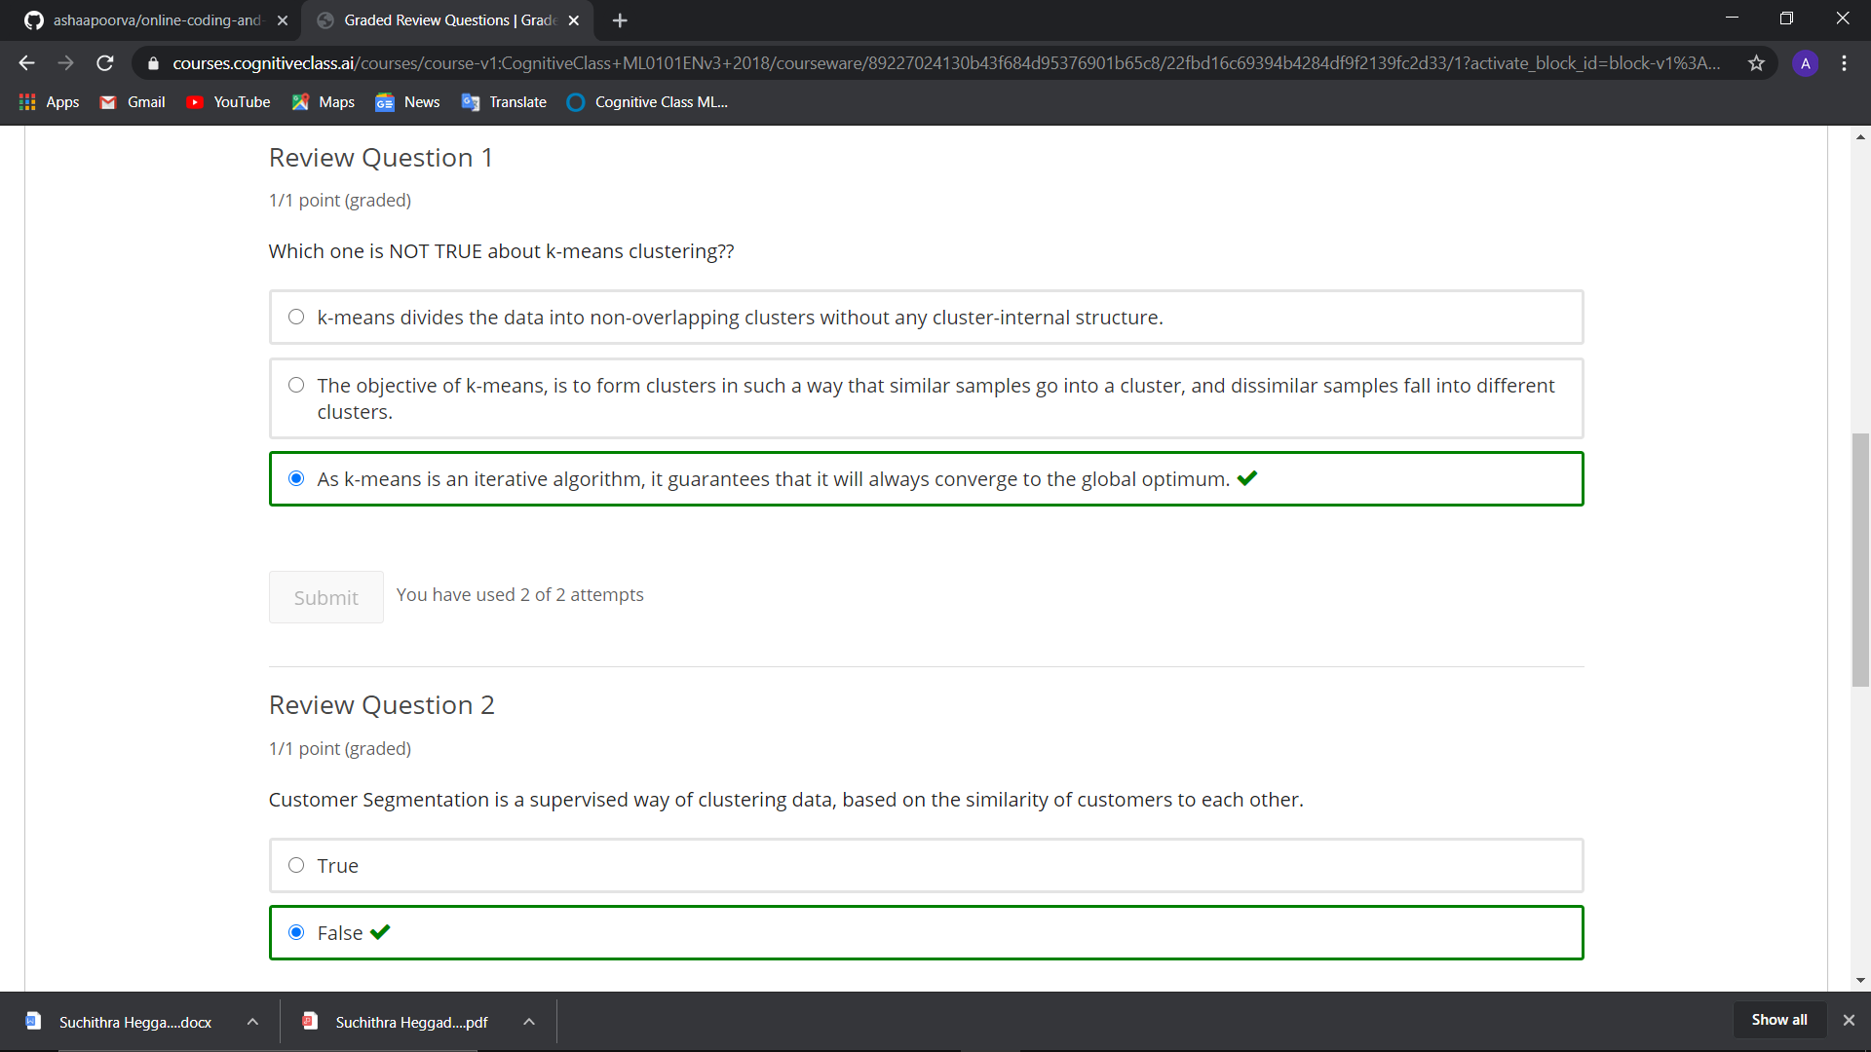

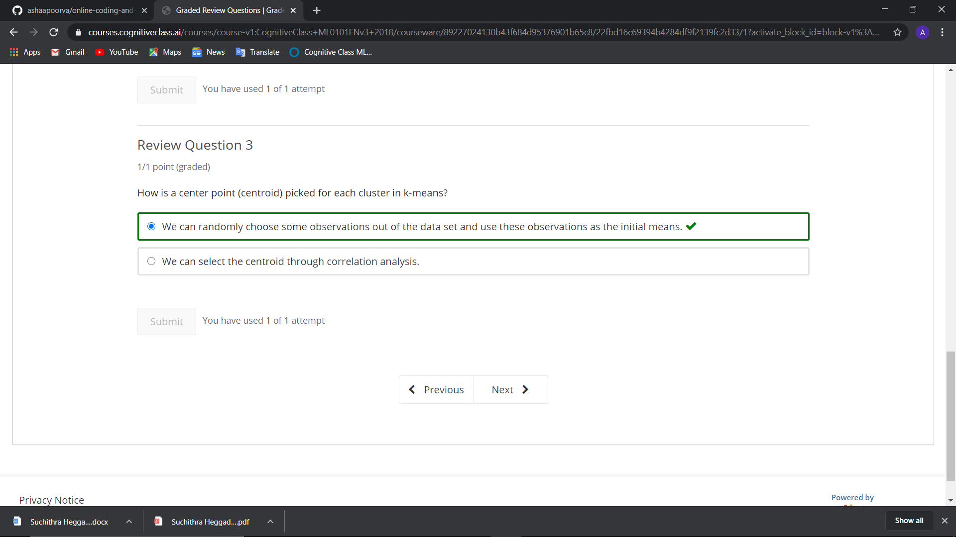

Coding Challenge Details

1. Python program to delete duplicate elements from the list

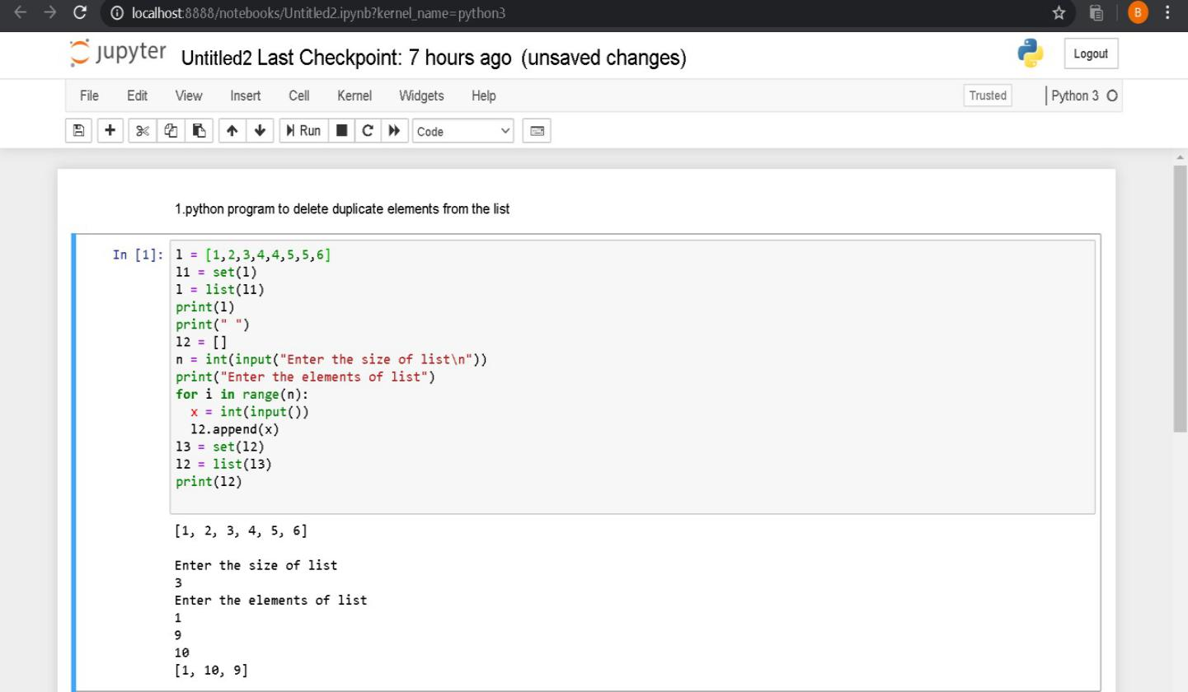

2.Python Program to remove duplicate elements from a list

